23rd Annual
National LawFit
Challenge

June 26-28, 2025

Hosted by:
LawFit/FireFit, LLC
Law Enforcement Agencies from Desoto County, Mississippi

www.lawfit.org


23rd Annual
National LawFit
Challenge

June 26-28, 2025

The LawFit Challenge consists of a series of six fitness and job- related competitive events:

- One Repetition Maximum Bench Press (Based on Percentage of Body Weight)
- One Minute Timed Sit-Up Test
- Sit and Reach Flexibility Test
- Pull-Ups
- 1.5 Mile Run
- 200 Yard Agility Course (Suspect Pursuit)

Scores for the event are age and gender adjusted to provide a fair and equitable competition for all participants.

Additional Info: www.lawfit.org

Who can participate? Current and retired local, state, federal and military law enforcement
personnel worldwide.

Registration Fee: $100 Per Participant ($125 for late registration after May 15, 2025)

Deadline: Entries must be registered by June 16, 2025

Hotel Registration: See attached list of local hotels.

Awards will be presented to the top teams & top competitors in the following categories:

* Overall Top performer
* Overall Individual Male and Female
* 4-Person Team
For further information, please contact:
Col. LeAnn Farr – 662-449-6907
Deputy Tim Presley – 901-570-1923
lawfit.desoto@gmail.com

* Men’s Pairs and Women’s Pairs
* Mixed Pairs (1-Man/1-Woman)
* Individual Event Winners

**Each competitor will compete in all events.

***Participants’ scores will be combined in the team categories.

Thursday, Friday & Saturday June 26-28, 2025
Desoto County, MS
**Registration Forms due by June 16, 2025**
APPLICANT INFORMATION

(Please type or print legibly.)
Participant’s Name: __________________________________________ DOB: ____________ ☐ M ☐ F

Agency Name: __________________________________________________________ Age: ___________

Agency Address: _________________________________________________________________________

Work Phone #: ______________Cell Phone #: _______________ Shirt Size: S__M__L__XL__ XXL__

Email Address: ___________________________________________________________________________

Do you require special accommodations under provision of the Americans with Disabilities Act? ☐ Y ☐ N
If yes, please state the nature of the accommodation required:
EXPRESSED ASSUMPTION OF RISK

I _______________________________________ am fit for full duty as a law enforcement officer and am physically able to participate in the 2025 National LawFit Challenge. I further recognize that this event’s physical activities (one repetition maximum bench press, 60-second sit-up test, sit & reach flexibility test, maximum repetition pull-up test, 1.5 mile run, and 200-yard suspect pursuit) have the potential to put significant stress on the cardiovascular and musculoskeletal systems of participants. Per the Manual of the World Anti-Doping Agency (WADA) and as a competitor in the LawFit Challenge, I attest that I have not used Performance Enhancing Drugs (PEDS) in preparation for this event. Additionally, I give LawFit and the host law enforcement agencies permission to use my photo and/or video for any purpose without compensation to me and such photos and/or video are the sole property of LawFit and the host law enforcement agencies.

Signature of participating officer: ___________________________________________________________________

Signature of agency supervisor: ___________________________________________________________________

Print name agency supervisor: ___________________________________________________________________

Phone Number: _______________ ____________Email: _____________________________ ___

Visit: www.lawfit.org
Registration - Make checks payable to: National LawFit Challenge

Mail this form and your registration check to: National LawFit Challenge
PO Box 723
Hernando, MS 38632

National LawFit Challenge

FITNESS TESTS

Bench Press

When ready to lift, the officer will take the bar out of the rack and lower it to his/her chest (at or slightly below nipple level). The lifter will pause the weight at chest level until the judge gives the command to press. At the command “Press,” the lifter will drive the weight upward until the arms are fully extended and hold this position until he/she is told to rack the weight. During this lift the officer must have both feet flat on the floor and his/her buttocks must remain in contact with the bench at all times.

One Minute Sit-Ups

The sit-ups will be performed on a padded floor mat. The officer's knees will be flexed at approximately a 90-degree angle and a spotter will anchor his/her feet in place. The officer will cross the arms and place his/her fingertips on the shoulders. A sit-up will be completed when the officer sits up and touches the top of the knees with his/her elbows, and then returns to the mat. Once the shoulder blades touch the mat, the officer can repeat the process. The officer should do as many as possible in one minute for the maximum accumulation of points. At all times the buttocks must remain in contact with the mat and the hands must remain on the shoulders.

Sit and Reach

The officer will sit on the floor with his/her bare or stockinged feet flat against the measuring box. A partner will hold the officer's knees to prevent them from bending as he/she moves forward. Placing one hand over the other, the person will reach out over the box as far as possible and return to the starting position. This will be repeated three times: the movement back and forth will be steady and smooth (no ballistic movements). On the third reach, the officer will hold his/her fingertips on the measuring box until the tester can record the measurement.

Pull-Ups

This test will be performed with the hands placed at shoulder width or wider on the bar with palms facing away from the body. In the starting position, the officer will hang from the bar with the arms fully extended. At the command “go” the officer will lift himself/herself up until the chin touches the bar, and then lower himself/herself back to the starting position. The officer will pause in the fully extended position (after each pull-up) until the “go” command is given by the judge. This motion will be repeated as many times as possible.

1.5- Mile Run

The 1.5-mile run is a timed event that will be completed on a marked street surface. Competitors will be equipped with computer chip technology to track and record their times.

National LawFit Challenge

* Using a laser targeting system, fire & hit target. A successful shot stops the clock.

**The officer then sprints 5 yards to the suspect; checks breathing & pulse and completes a cycle
of 30 chest compressions. Inadequate performance of this task results in a 5 second penalty.

Handcuff Suspect Run 50 yds * **
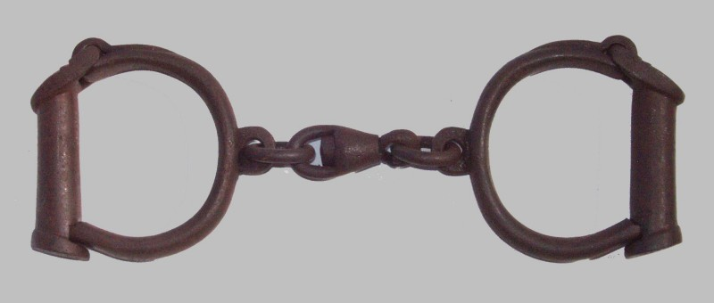
Officer is given a
Run 20 yds suspect description.
Time begins when
Drag Victim monitor says “GO”.
START
5 yds.
150 lbs.
Run 25 yds Run 15 yds

1 2 3 4
Jump 3 ft
Identify Suspect

Run 10 yds Run 25 yds

Run 15 yds
Run 10 yds
Run 25 yds
Climb 8” step
Climb through window up and down 12 times Climb over
36”w X 30”h X 3’ (up/up – down/down) Crawl under 5 ft. wall
above the ground obstacle
2’h X 10’l

23rd Annual
National LawFit
Challenge

June 26-28, 2025

HOTEL INFORMATION

Official Hotel

*Fairfield Inn and Suites Silo Square
6497 Front St.
Southaven, MS 38672
662-222-1960

Local Hotels

Holiday Inn
280 Marathon Way
Southaven, MS 38671
662-349-0444

Homewood Suites
135 Homewood Drive
Southaven, MS 38671
662-349-0501

Home2Suites
6750 Southcrest PKWY
Southaven, MS 38671
662-349-8804

