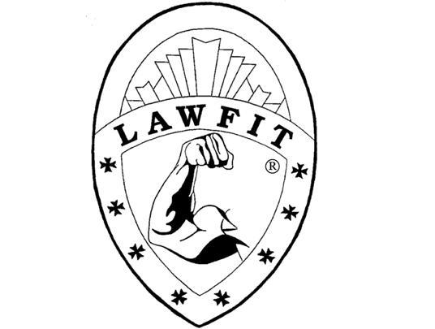

To: LAWFIT® Workshop Participants

From: Dr. David L. Bever

Re: LAWFIT® Fitness Leadership Workshop Materials and Training Gear

LAWFIT® Workshop participants will meet at the Central Virginia Criminal Justice Academy, 1200 Church St., Lynchburg, VA 24504 for each day’s classes.

1. Throughout each day participants will need to wear workout apparel (shorts, warm-ups, sweatpants, t-shirts, and running shoes). **No street clothes please.** Because of the vigorous activity schedule, it is suggested that each officer bring two sets of workout gear: (one for the morning sessions and one for the afternoon sessions). **During work performance testing it is suggested that participants wear BDU’s, an agency t-shirt or sweatshirt, and their personal protective vests.**
2. All participants will need to bring a combination lock for storage of valuables during the activity sessions. They will also need to bring two towels for post-workout showers.
3. Participants should bring several pens, No. 2 pencils, a cell phone/tablet/calculator, **your laptop** and a notebook to each workshop session.
4. If you have any questions about the LAWFIT® Workshop, Dr. Bever can be reached at:

(703)-591-1759 or (703)-424-6154.

**\*\* Officers should be in fitness gear at 0800 on the first day of the Workshop.**

**\*\*\* DURING WORKSHOP SESSIONS CELL PHONES MUST BE TURNED OFF AND STORED AWAY. MESSAGES CAN BE CHECKED AT ASSIGNED BREAKS.**

**☺☺☺☺☺**

1. **In light of the Coronavirus situation, I am requesting that attending officers bring personal protective masks in case they are needed during training. (Per CDC Guidelines of 13 May 2021).**
2. **In utilizing our fitness and medical equipment, officers will be expected to sanitize the units with provided disinfecting agents after each use.**
3. **During classroom/lecture sessions officers will follow social distancing protocols. With everyone’s assistance, we will make this a positive and safe training experience.**